**FPT ACADEMY INTERNATIONAL**

## FPT – APTECH COMPUTER EDUCATION





| **Center Name** | | FPT – Aptech – HCM2  Address: 590 Cach Mang Thang Tam, District 3, Ho Chi Minh City | |
| --- | --- | --- | --- |
| **Instructor** |  | Ms. Le Mong Thuy |  |
| **Class** |  | T1.2205.M0 |  |
| **Group** |  | 2 |  |
| **Group members** | | **Name** | **Student ID** |
|  |  | Nguyen Tien Ngoc | Student1381862 |
|  |  | Nguyen Minh Tri | Student1385144 |
|  |  | Vo Hung Viet Nhut | Student1385145 |
| **Duration** | Start date | 19th August 2022 |  |
| End date | 19th September2022 |  |

**This is to certify that**

**Mr.:**

Nguyen Tien Ngoc

Nguyen Minh Tri

Vo Hung Viet Nhut

**has successfully designed & developed**

eProject: Fanimation website

**Submitted by:**

Nguyen Tien Ngoc

**Date of issue:**

**Authorized Signature:**

**TABLE OF CONTENTS**

***FPT – APTECH COMPUTER EDUCATION***

***TABLE OF CONTENTS*** ***2***

***ACKNOWLEGMENT*** ***3***

***SYNOSIS*** ***3***

***PROBLEM DEFINITION*** ***3***

***CUSTOMER'S REQUIREMENTS SPECIFICATIONS (CRS)***

***Business/Project Objective*** ***4***

***Hardware/ Software Requirements*** ***5***

***SCOPE OF THE WORK (IN BRIEF)***

***Architecture and design of the system***

***Diagram of the website***

***TASK SHEET REVIEW 1***

***SITE MAP 10***

***MOCK OF THE WEBSITE*** ***1***

***1. Homepage*** ***1***

***2. Product*** ***2***

***3.*** **Gallery** ***3***

***3. Blog*** ***4***

***4. About Us 1******4***

***5. Contact US*** ***5***

***6. Service*** ***6***

***7. Sign In/ Sign Up*** ***7***

***TASK SHEET REVIEW 2 18***

***WEBSITE DESCRIPTION*** ***9***

***RESPONSIVE*** ***28***

***JAVASCRIPT DESCRIPTION*** ***30***

***TASK SHEET REVIEW 3*** ***47***

# ACKNOWLEGMENT

On behalf of team members. I would like to thank everyone who supported my team to successfully complete this eProject report. Especially, our teacher, she has supported us a lot since we started studying at FPT Aptect. With this eProject, she guided us very meticulously, enthusiastically and strictly. With her guidance, we were able to successfully complete this project. Besides, I also want to thank all the team members, each of whom worked hard to complete the eProject in earnest during the month of working together. Finally, our group would like to say thank you to my classmates and family for sharing and creating for the group the best environment to focus on the project, motivating the members to achieve their goals.

# SYNOSIS

# The goal of the eProject is that we need to create a website that meets all the requirements of the client, Harvel Electric. Harvel Electric is an energy company specializing in the supply of various electrical products. They always satisfy customers with professional staff with many years of experience. The main goal of this website is to reach customers who need the best quality electrical products for their home or company. In addition, the products have discounts and promotions for customers, especially the company also supports the direct installation of their products. Customer satisfaction is always the top goal of Harvel Electric.

# PROBLEM DEFINITION

Fanimation is in the business of revolutionizing home appliances, by solving one

problem at a time. Every household appliance we create blends mindful design, energy-

efficiency and next-gen smart tech.

We think, dream and obsess over customer experience. We are Fanimation.

Fanimation is a global manufacturer of standard and custom fans and fan accessories.

With over 40 years of experience, Fanimation has been supplying quality engineered

cooling products and assemblies to a wide range of industries and applications.

Fanimation has engineering, sales, and manufacturing facilities.

Fanimation strives hard to be environmentally friendly. We encourage you to browse our

products online, which includes all the latest information on our great products and

styles.

You are supposed to create a Single-Page-Application and responsive Website for

them with the below mentioned requirement specifications.

The website is to be developed for the Windows Platform using HTML5, JSON,

Angular JS, JavaScript and Geolocation. The site should work well in all leading

browsers including Chrome, IE, Firefox etc.

# CUSTOMER'S REQUIREMENTS SPECIFICATIONS (CRS)

**Client: Fanimation**

### Business/Project Objective:

### The website is to be developed for the Windows Platform using HTML5, JavaScript and Geolocation. The site should work well in all leading browsers including Chrome, IE, Firefox etc.

The portal will be designed as a Single-Page-Application and responsive Website with

a set of pages and menus that represent choice of activities to be performed. The

pages, menus, and other visual elements must be designed in a visually appealing

manner with attractive fonts, colors, and animations.

All of these should also be laid out in a responsive manner  
  
 **Process**:

* + - * Validate data input from users.

**Expected delivery date:** 19-Sep-2022.

**List of deliverables:**

- Document Word, PDF.

- User Guide.

- Source code.

### Hardware/ Software Requirements:

* **For developer**

**Hardware**

* + Intel Pentium 4 processor or higher
  + 01 Gigabytes of RAM or higher

**Software**

* + Windows 7 OS or higher
  + Adobe Dreamweaver
  + Web browsers such as IE, Chrome or Firefox are supporting HTML5, CSS3 and Javascript.
* **For web users**

**Hardware**

* + Intel Pentium 4 processor or higher
  + 512 Megabytes of RAM or higher

**Software**

* + Windows XP OS or higher
  + Web browsers such as IE, Chrome or Firefox are supporting HTML5, CSS3 and Javascript.

# SCOPE OF THE WORK (IN BRIEF)

After a long and detailed discussion, our group has decided to create a website contain the following webpages:

1. ***Homepage***: There is a search bar to search for products, display promotional information, best-selling products and introduce Fanimation.
2. ***Product***: Displays all available products based on the Category category (Ceiling fans, Pedestal fans, Wall fans, Exhaust fans, Accessories). In the above categories, products can be filtered by name, capacity and price.
3. ***Gallery***: Display for viewing different images.
4. ***Blog***: Display articles, news, equipment installation instructions...
5. ***About Us***: Display the information of the company, clients’ review and about us.
6. ***Contact Us***: Display the address of the company, Map and allow customers to request any information they want to Fanimation.
7. ***Sign In/ Sign Up***: Allow users sign up or sign in to the website.

# ARCHITECTURE AND DESIGN OF THE SYSTEM

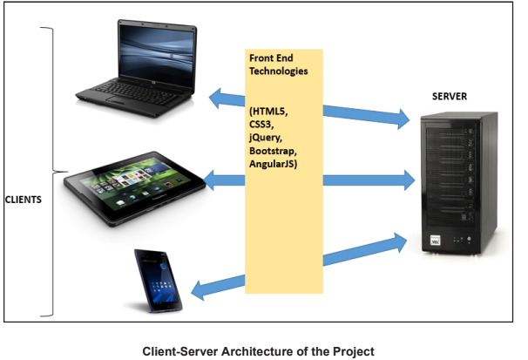

# 

# DIAGRAM OF THE WEBSITE

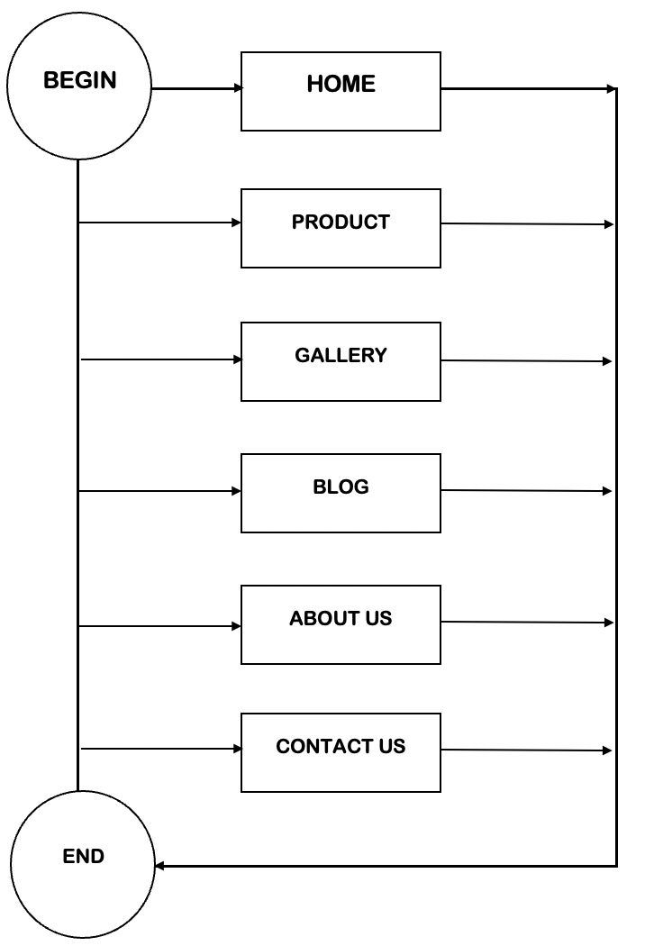



# TASK SHEET REVIEW 1

| **Project Ref. No.:**  **eP/Advertisement Portal Management**  **System/01** | | **Project Title:** | **Activity Plan Prepared By:** | **Date of Preparation of Activity Plan:** | | | |
| --- | --- | --- | --- | --- | --- | --- | --- |
| **Sr.**  **No.** | **Task** | **Actual**  **Start**  **Date** | **Actual Days** | **Team**  **Mate Names** | **Status** |
| 1 | Problem Statement | FANIMATION | Ngoc | 19-Aug-2022 | 1 | Tri | Completed |
| 2 | Analysis of Harvel Electric requirements about the website | 19-Aug-2022 | 1 | Tri | Completed |
| 3 | The scope of the work (in brief) | 19-Aug-2022 | 1 | Ngoc | Completed |
| 4 | Architecture and design of the system | 19-Aug-2022 | 1 | Ngoc | Completed |
| 5 | Diagram of the website | 19-Aug-2022 | 1 | Nhut | Completed |
| 6 | Task Sheet | 19-Aug-2022 | 1 | Nhut | Completed |

| **Date:** | |
| --- | --- |
| Signature of Instructor:  **Ms. Le Mong Thuy** | Signature of Team Leader:  **Nguyen Tien Ngoc** |

# SITE MAP

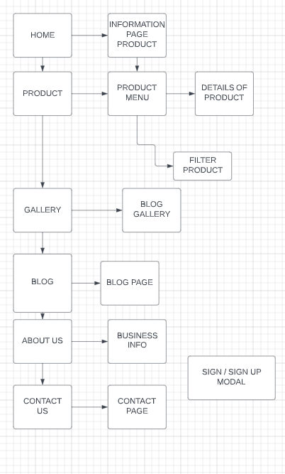

# MOCK OF THE WEB SITE

1. **Homepage**

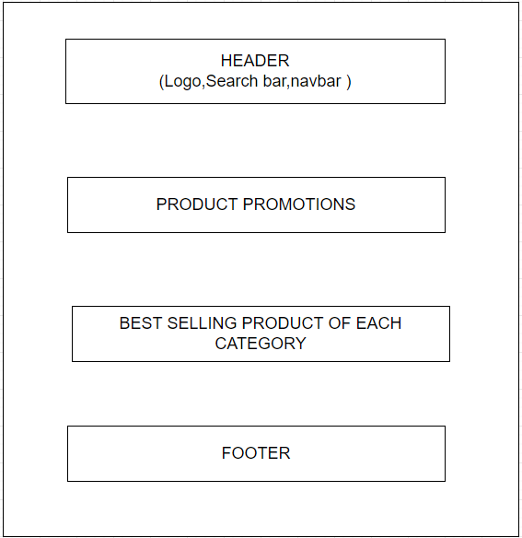

1. **Product**

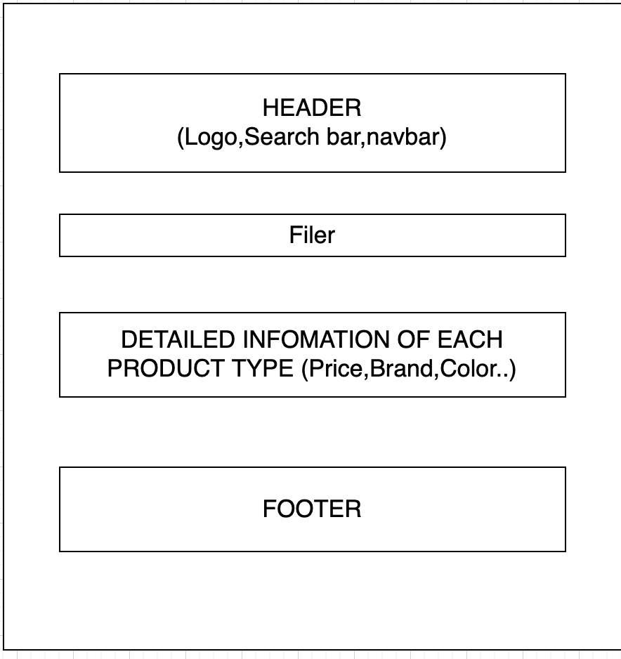

1. **Gallery**

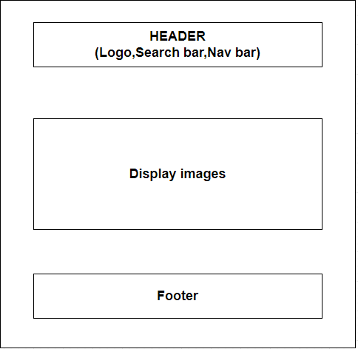

1. **Blog**

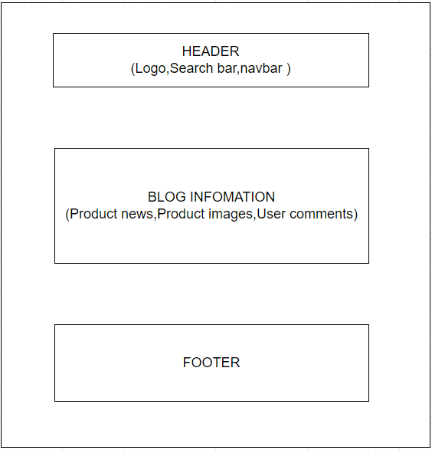

1. **About Us**

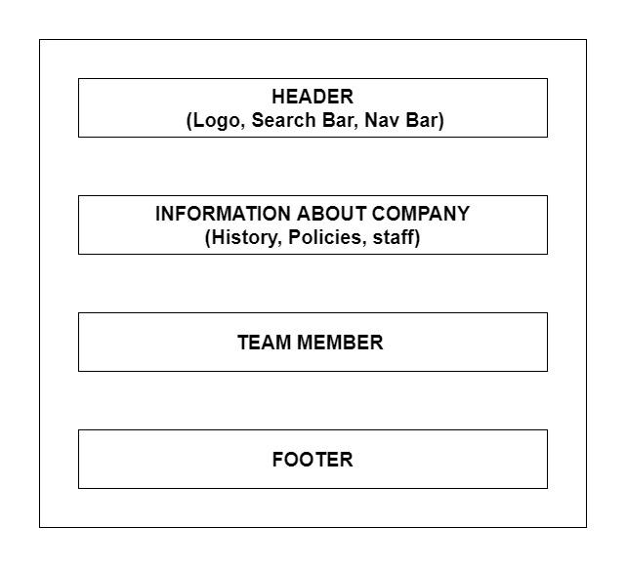

1. **Contact Us**

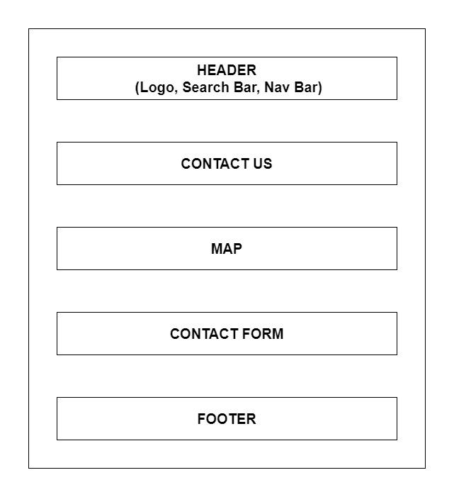

1. **Sign In/ Sign Up**

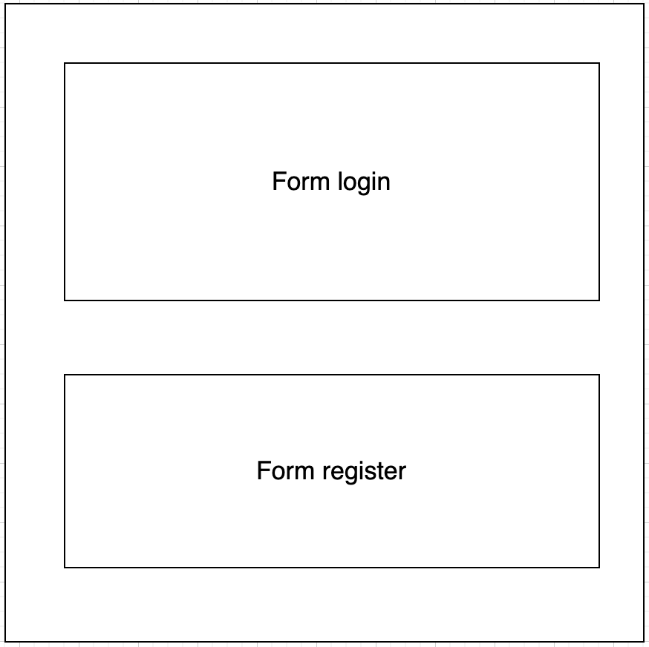

# TASK SHEET REVIEW 2

| **Project Ref. No.:**  **eP/Advertisement Portal Management**  **System/01** | | **Project Title:** | **Activity Plan Prepared By:** | **Date of Preparation of Activity Plan:** | | | |
| --- | --- | --- | --- | --- | --- | --- | --- |
| **Sr.**  **No.** | **Task** | **Actual**  **Start**  **Date** | **Actual Days** | **Team**  **Mate Names** | **Status** |
| 1 | Site Map | FANIMATION | Ngoc | 21-Aug-2022 | 1 | Tri | Completed |
| 2 | Mock of the website | 21-Aug-2022 | 2 | Ngoc | Completed |
| 3 | Task sheet | 21-Aug-2022 | 2 | Nhut | Completed |

| **Date:** | |
| --- | --- |
| Signature of Instructor:  **Ms. Le Mong Thuy** | Signature of Team Leader:  **Nguyen Tien Ngoc** |

1.HEADER

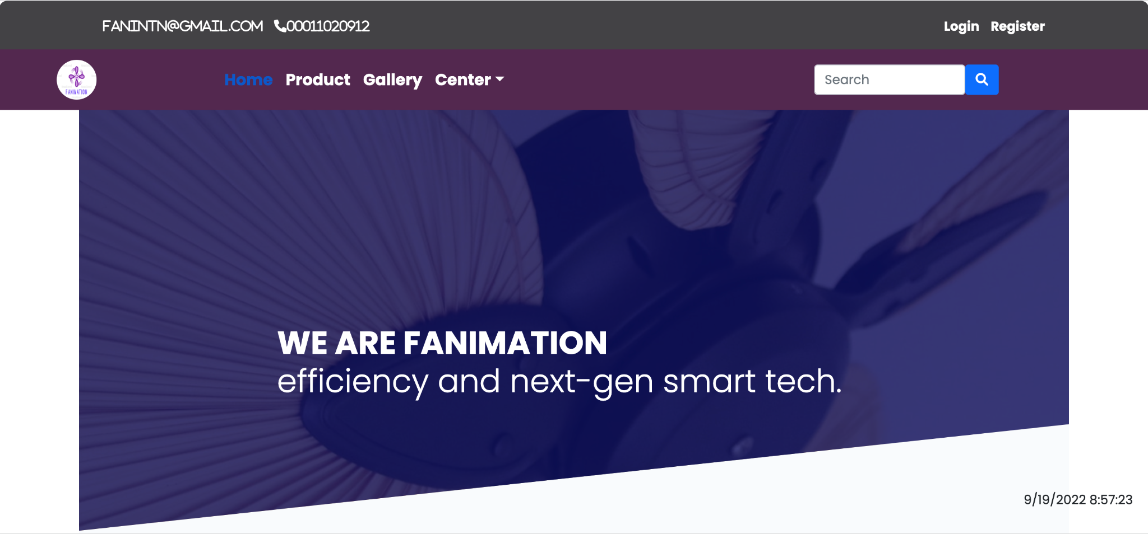

2. login/register

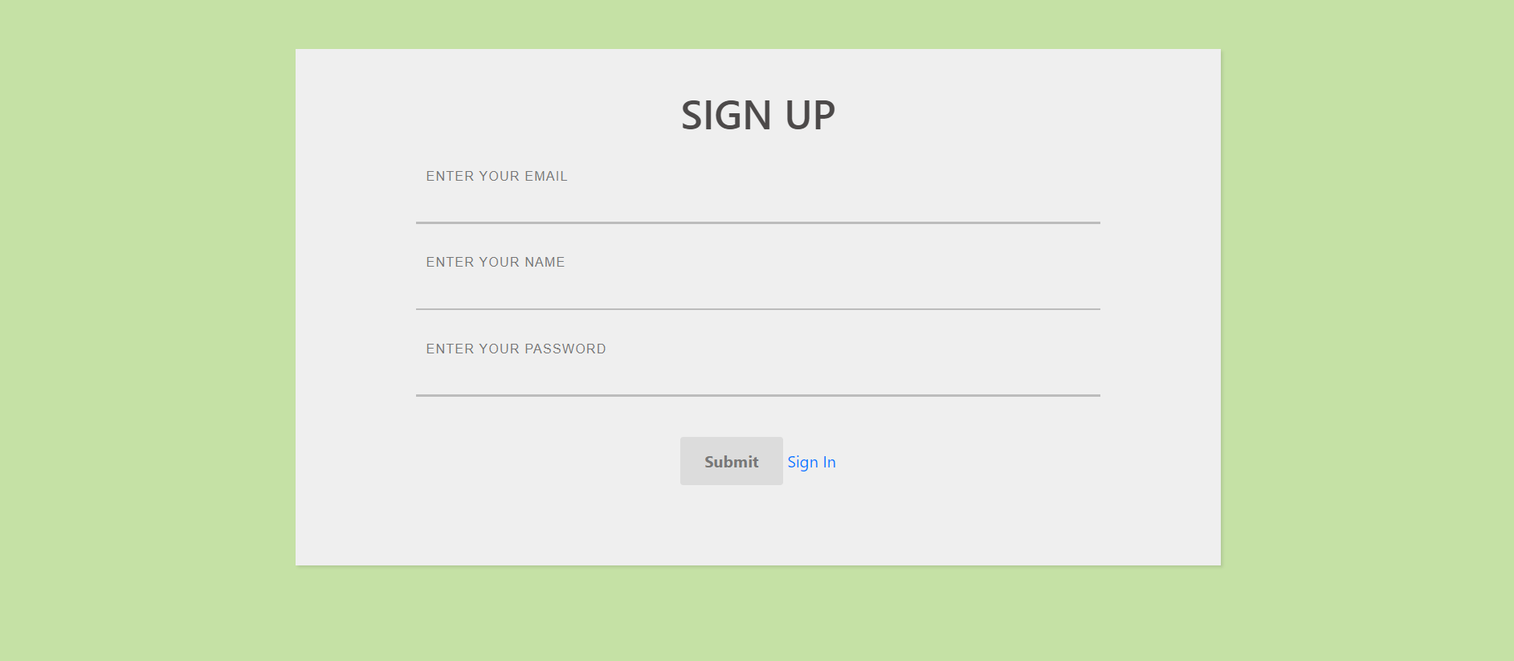

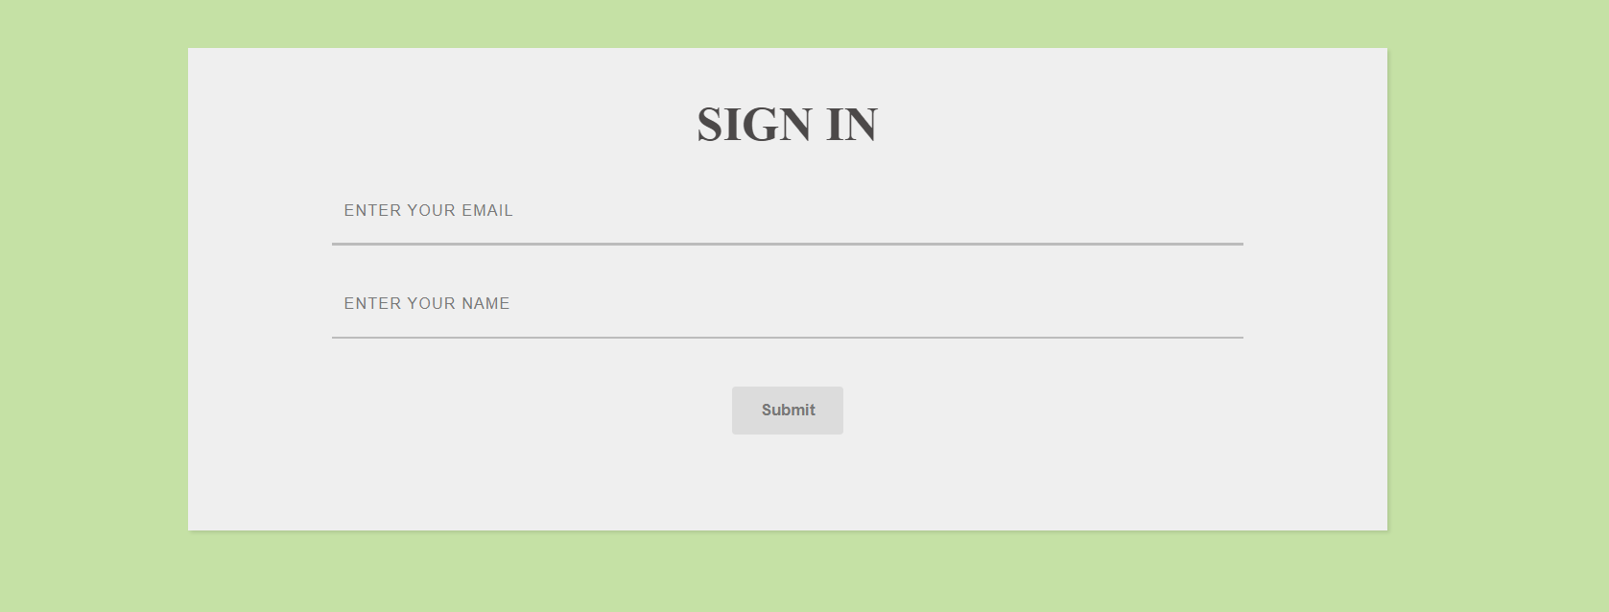

2. Product

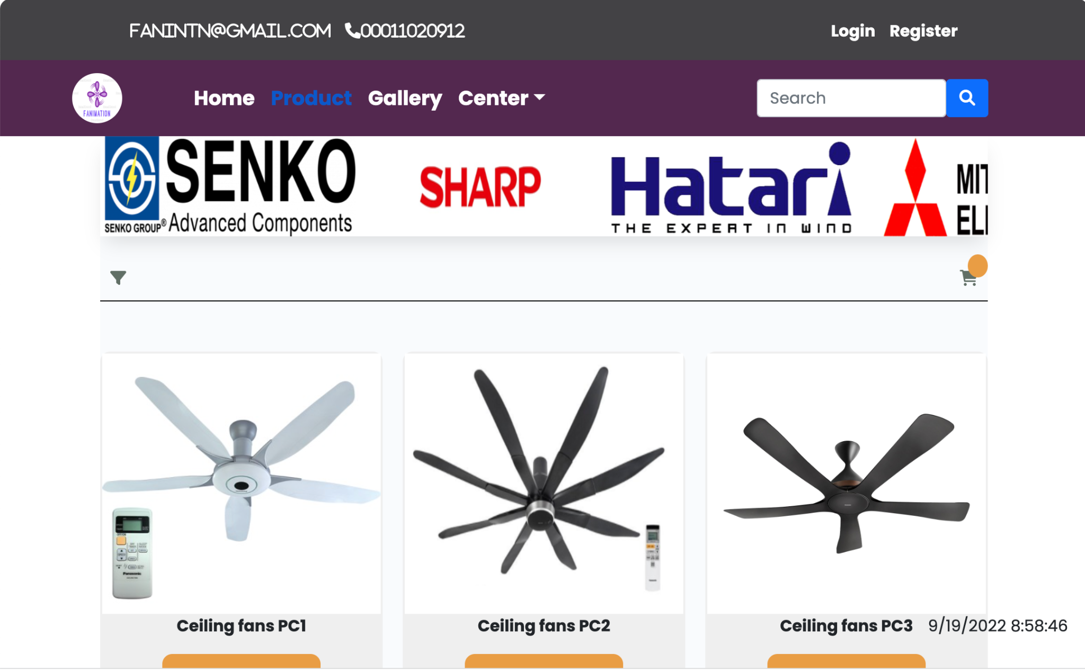

4.Gallery

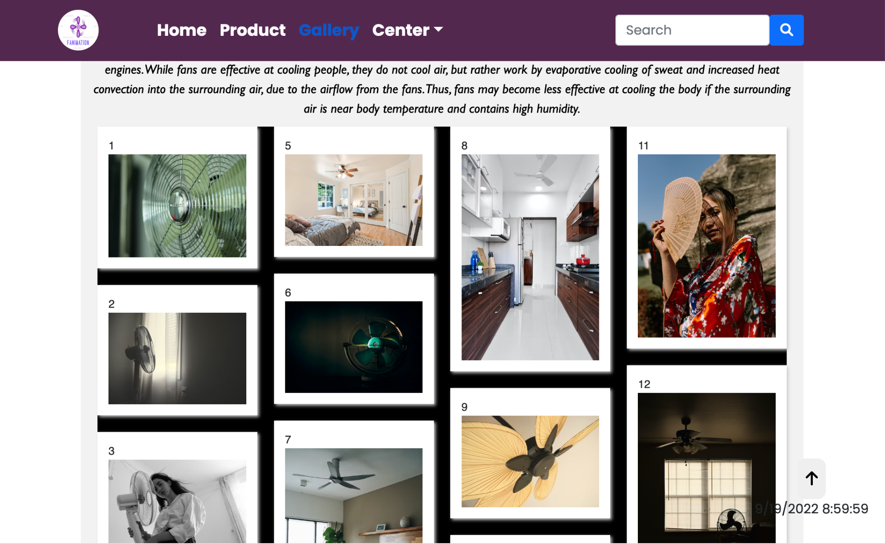

5.About us

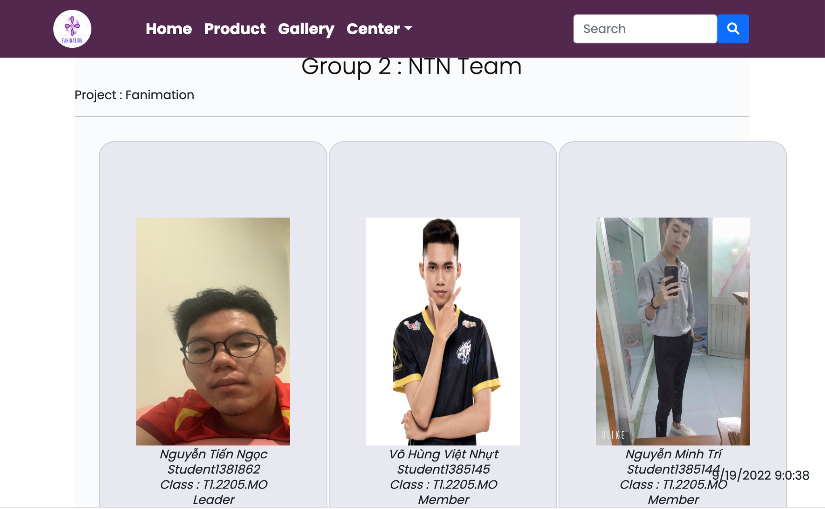

6.Contact us

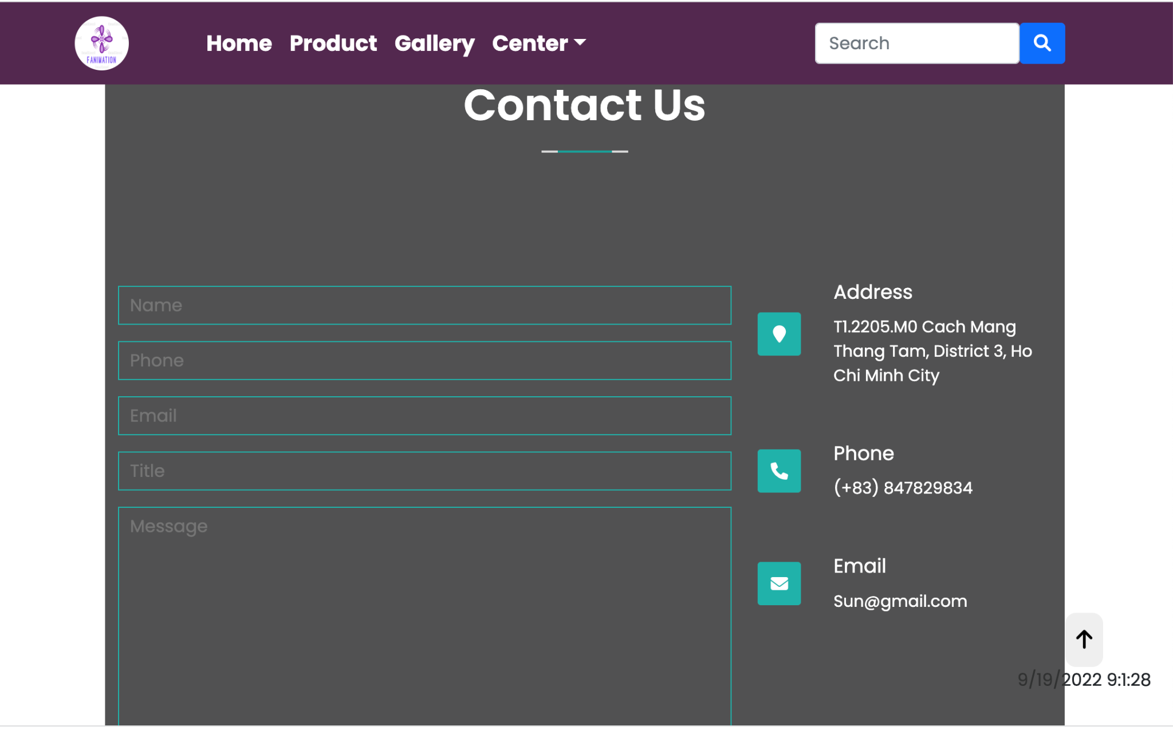

8.FAQ

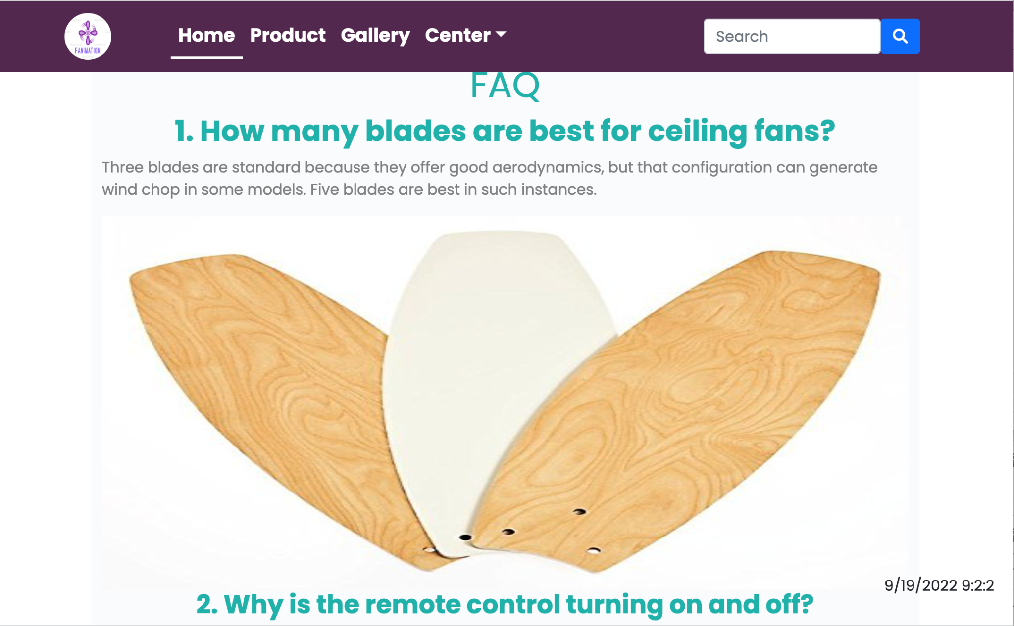

8.Blog

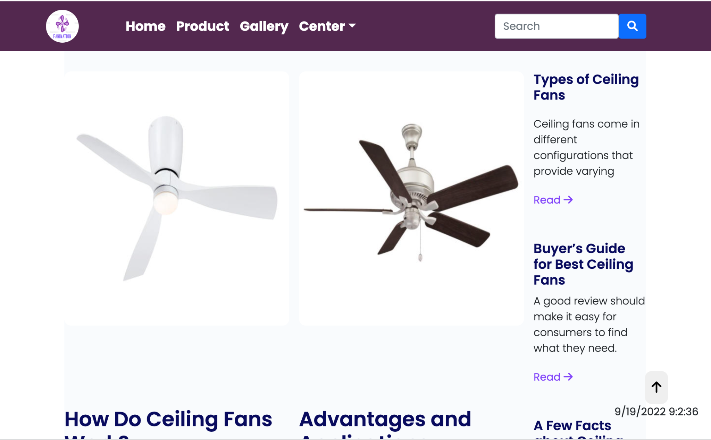

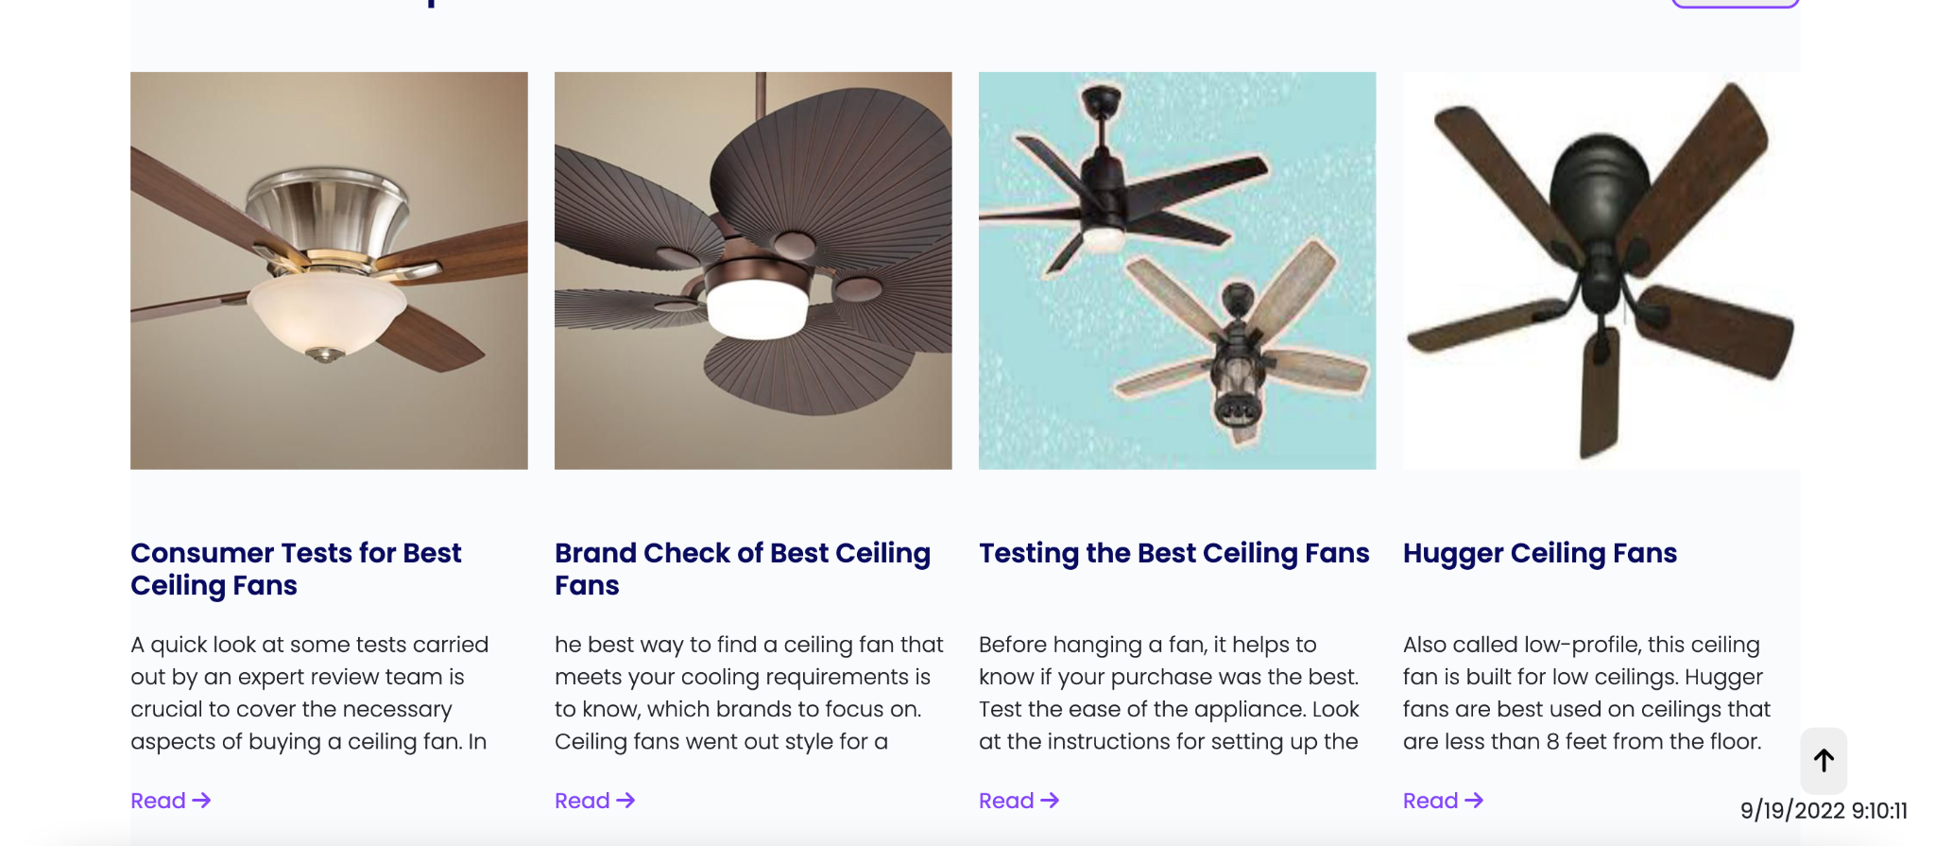

# TASK SHEET REVIEW 3

| **Project Ref. No.:**  **eP/Advertisement Portal Management**  **System/01** | | **Project Title:** | **Activity Plan Prepared By:** | **Date of Preparation of Activity Plan:** | | | |
| --- | --- | --- | --- | --- | --- | --- | --- |
| **Sr.**  **No.** | **Task** | **Actual**  **Start**  **Date** | **Actual Days** | **Team**  **Mate Names** | **Status** |
| 1 | Home Page | Fanimation | Ngoc | 18-Aug-22 | 3 | Ngoc | Completed |
| 2 | Product | 20-Aug-22 | 5 | Ngoc | Completed |
| 3 | Blog | 18-Aug-22 | 2 | Nhut | Completed |
| 4 | About Us | 20-Aug-22 | 2 | Tri | Completed |
| 5 | Contact Us | 18-Aug-22 | 2 | Nhut | Completed |
| 6 | Sign In/ Sign Up | 22-Aug-22 | 1 | Tri | Completed |
| 7 | Java Script | 23-Aug-22 | 5 | ngoc | Completed |
| 8 | Responsive | 22-Aug-22 | 1 | Tri | Completed |

| **Date:** | |
| --- | --- |
| Signature of Instructor:  **Ms. Le Mong Thuy** | Signature of Team Leader:  **Nguyen Tien Ngoc** |